COMPREHENSIVE CLIENT INFORMATION SHEET
Fascial Stretch Therapy

Instructions: This is your comprehensive information sheet. All relevant, personal information is gathered to equip the therapist with essential information used to deliver an optimal, results driven program. Please answer all questions accurately, honestly, and as detailed as possible.

Disclaimer: Please recognize the fact that it is your responsibility to work with your physician before, during, and after seeking consultation. As such, any information provided is not to be followed without the prior approval of your physician. If you choose to use this information without the prior consent of your physician, you are agreeing to accept full responsibility for your decision.

Part 1: Basic Information

Name: ____________________________________ Gender: __________ D.O.B: ______/______/_____ Age_______

Email: ______________________________________________ Contact Number: _____________________________

Part 2: Session Information

What is your main reason for receiving therapy? _______________________________________________________________

What specific goals would you like to receive from therapy? _____________________________________________________

How did your symptoms begin? ____________________________ When did symptoms begin? ________________________

Please mark on the figures where symptoms are located:

Are you currently, or have been, under medical supervision for this problem? YES ______ NO ______

Have you had any tests for this problem (x-rays, MRI, CT-scan)? _________________________________________
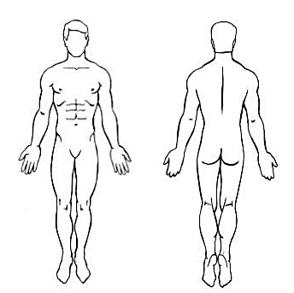
Please describe your symptoms. Circle all that apply:

-Dull -Ache -Burning -Sharp -Periodic -Constant

-Sore -Stiff -Numb -Tingling

What makes your symptoms better or worse?

___________________________________________________

___________________________________________________

Do you have chronic or frequent pain? ______________________

On a scale from 1-10, 10 being the most severe pain possible, what is your discomfort level now? ______________________

Part 3: Physical/Lifestyle Factors

Please list any supportive braces worn? _______________________ Do you wear orthotics? YES______ NO _____

Have you ever had chiropractic treatment? YES ______ NO _____ How often? ____________

Have you experienced any bodywork (massage, acupuncture, etc)? YES _____ NO _____ If so, what type? _______________

How often do you receive bodywork? __________________

Are you currently exercising regularly? YES___ NO ___ How does exercising impact your symptoms? ___________________

Do you currently stretch? YES ___ NO __ If so, how often? ________

Do you believe flexibility is an important part of fitness and overall health? YES ______ NO _______

What percentage of your day is spent sitting? ________ Standing? ________ Driving? ________ Physical Labor? ________

How do you rate your posture? ______________________________________________

Part 3: Medical History

Have you been diagnosed with any health problems? If so, please list the condition(s): _________________________________

______________________________________________________________________________________________________

Are you currently on any medications (including over-the-counter medication like ibuprofen)? If so, please list them.

_____________________________________________________________________________________________________

Please list any supplements that you are currently taking: _______________________________________________________

Are you currently under care of a physician? YES _____ NO _____ If yes, please explain: ____________________________

Please list any injuries, accidents or surgeries and date of event: __________________________________________________

______________________________________________________________________________________________________

Are there any other medical conditions that the therapist should be aware of? ________________________________________

The above information is accurate and true to the best of my knowledge. If there are any changes in my current level of health, I will inform the person I am being treated by of my condition. I understand that this business does not diagnose or treat illness and/or disease and does not prescribe medications. I agree to pay my account with this business in accordance with the regular rates and payment terms. If, for any reason cancellation is necessary, I will give a 24-hour notice. I understand that if I do not give this notice, I will be charged for the appointment unless it can be filled. The owner will determine emergency cancellations. It is agreed that any claim of liability is hereby waived.

______________________________________________________ _____________
Signature Date

